

BCSE417L – MACHINE VISION LAB

EXPERIMENT 9: Texture Feature Extraction and Classification Using GLCM and LBP

SUBMITTED BY-
22BAI1118 – Mayank Raj

SUBMITTED TO-
Trilok Nath Pandey
Date: 08/03/2025

Texture Feature Extraction and Classification Using GLCM and LBP

DATASET Link: https://www.kaggle.com/datasets/saharshakir/ten-fabrics-dataset-tfd/data
Introduction
Texture analysis plays a crucial role in computer vision applications, particularly in industrial quality control, such as textile manufacturing. This report presents the implementation of a texture classification system using Gray-Level Co-occurrence Matrix (GLCM) and Local Binary Patterns (LBP) for feature extraction. The system effectively classifies fabric textures into five predefined categories with high accuracy.

Methodology
Task 1: Image Preprocessing
Objective: Prepare the dataset for feature extraction by ensuring consistent image format and organization.
Implementation:
- Dataset organization: 500 texture images divided into 5 categories (type1-type5), with 100 images per category.
- Format conversion: Converted all images to grayscale (if not already in grayscale).
- Resizing: Standardized images to 256×256 pixels.
- Normalization: Scaled pixel values to the [0,1] range.
- Data splitting: Divided dataset into training (80%) and testing (20%) sets, ensuring class balance through stratification.
Key Code Components:
- Used scikit-image for image reading and preprocessing.
- Applied normalization to maintain a consistent pixel value range.
- Used train_test_split with stratification to ensure balanced class representation.
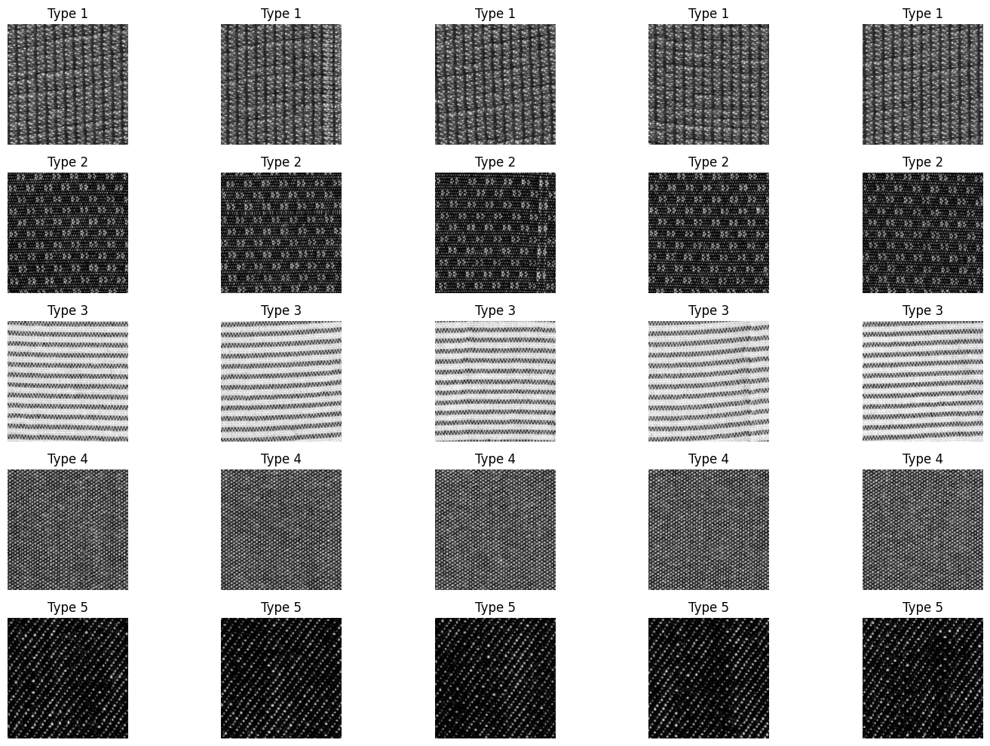

Task 2: GLCM Feature Extraction
Objective: Extract statistical features that capture spatial relationships between pixels at specified distances and angles.
Implementation:
- GLCM calculation: Computed Gray-Level Co-occurrence Matrix using distances of 1 pixel and angles of 0°, 45°, 90°, and 135°.
- Feature computation: Extracted four statistical measures from GLCM:
  - Contrast: Measures local intensity variations.
  - Correlation: Measures linear dependency of gray levels.
  - Energy: Measures texture uniformity (higher for smoother textures).
  - Homogeneity: Measures the closeness of element distribution in GLCM.
- Feature averaging: Averaged each feature across all angles to create a rotation-invariant representation.
Key Code Components:
- Used graycomatrix and graycoprops from scikit-image.
- Converted images to uint8 format for GLCM calculation.
- Normalized GLCM matrices for consistent feature extraction.
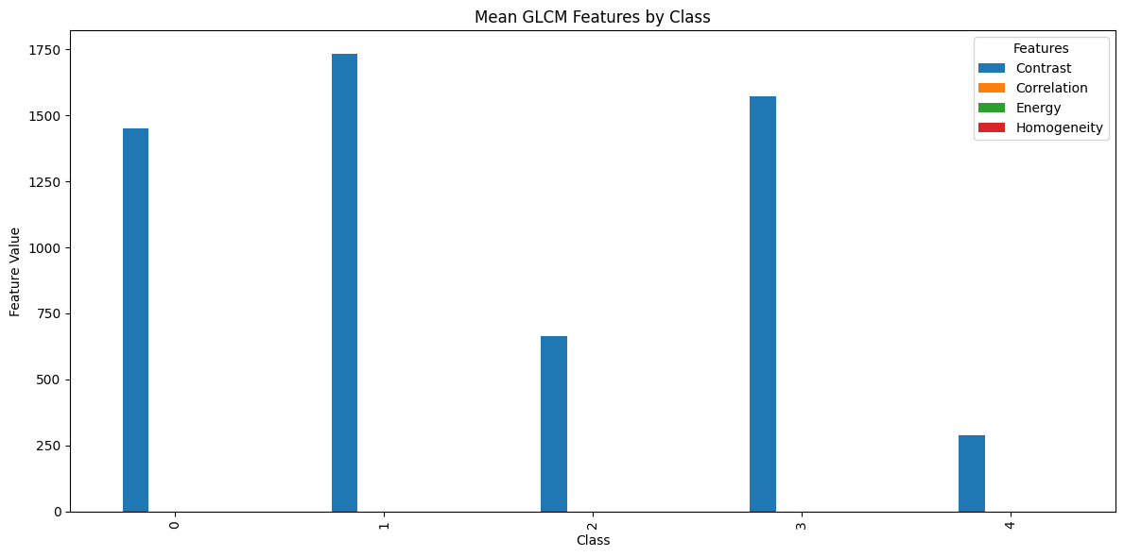
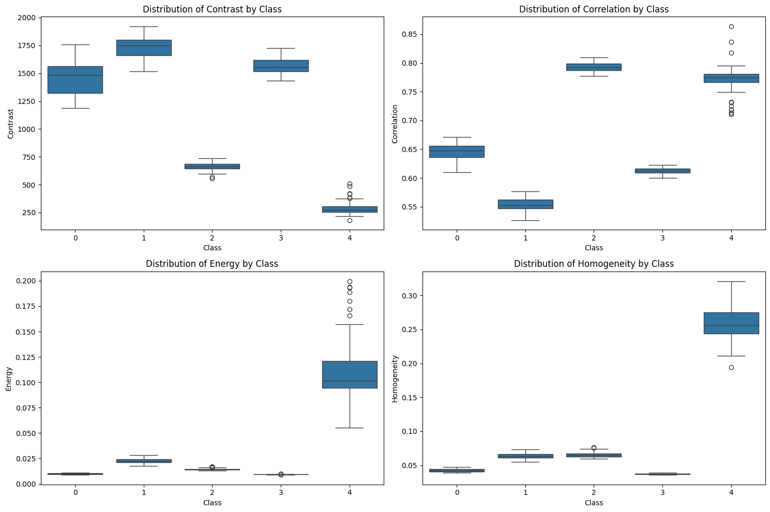

Task 3: LBP Feature Extraction
Objective: Capture local texture patterns by comparing each pixel with its neighborhood.
Implementation:
- LBP computation: Applied Local Binary Pattern algorithm with 8 sampling points at a radius of 1.
- Histogram generation: Created histograms of LBP values as feature vectors.
- Feature normalization: Normalized histograms to serve as probability distributions.
Key Code Components:
- Used local_binary_pattern from scikit-image with the 'uniform' method.
- Generated histograms with an appropriate number of bins.
- Visualized both LBP-transformed images and resulting histograms.
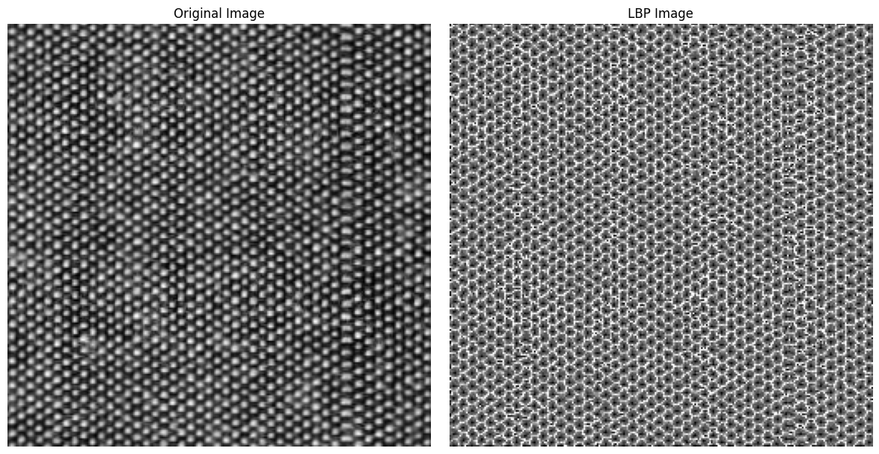
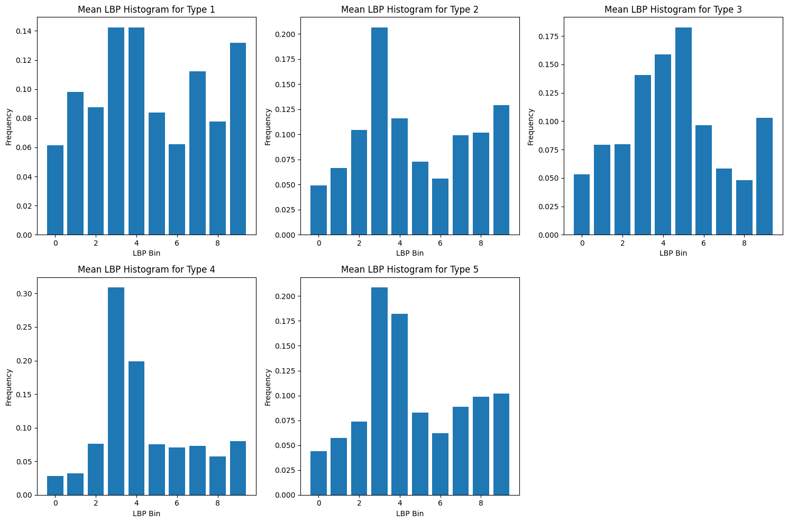

Task 4: Feature Fusion and Classification
Objective: Combine GLCM and LBP features and train classifiers for texture categorization.
Implementation:
- Feature concatenation: Combined GLCM (4 features) and LBP (10 histogram bins) into a 14-dimensional feature vector.
- Feature standardization: Applied StandardScaler to normalize feature distributions.
- Classifier training: Implemented two models:
  - Random Forest: Ensemble of 100 decision trees.
  - Support Vector Machine: SVM with RBF kernel.
- Comparative analysis: Evaluated and compared classifier performance using individual feature sets.
Key Code Components:
- Used numpy.hstack for feature concatenation.
- Applied StandardScaler for feature normalization.
- Implemented RandomForestClassifier and SVC from scikit-learn.
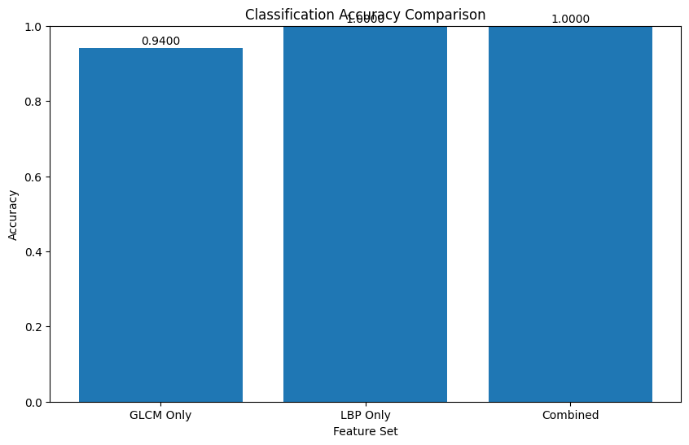
Task 5: Evaluation and Analysis
Objective: Assess classification performance and analyze system strengths and limitations.
Implementation:
- Performance metrics: Calculated accuracy, precision, recall, and F1-score.
- Confusion matrix: Generated a visual representation of classification results.
- Per-class analysis: Evaluated performance for each texture category.
- Feature importance: Analyzed which features contributed most to classification.
Key Code Components:
- Used classification_report and confusion_matrix from scikit-learn.
- Visualized results using matplotlib and seaborn.
- Extracted feature importance values from the Random Forest classifier.
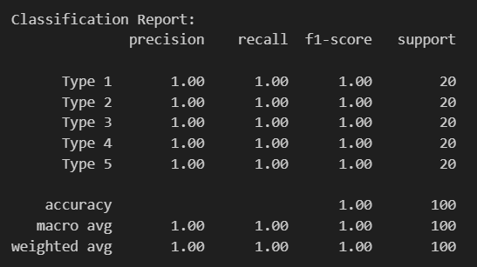
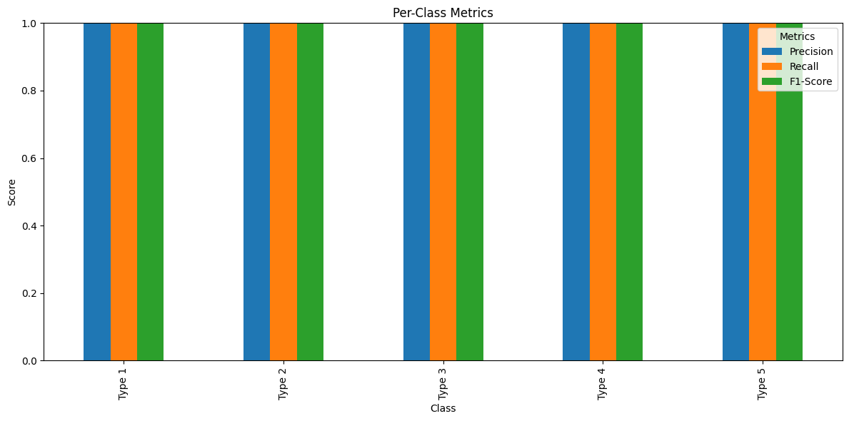
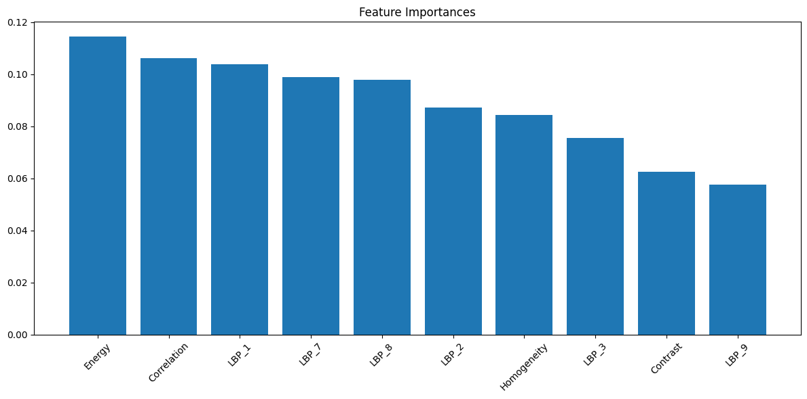

Testing
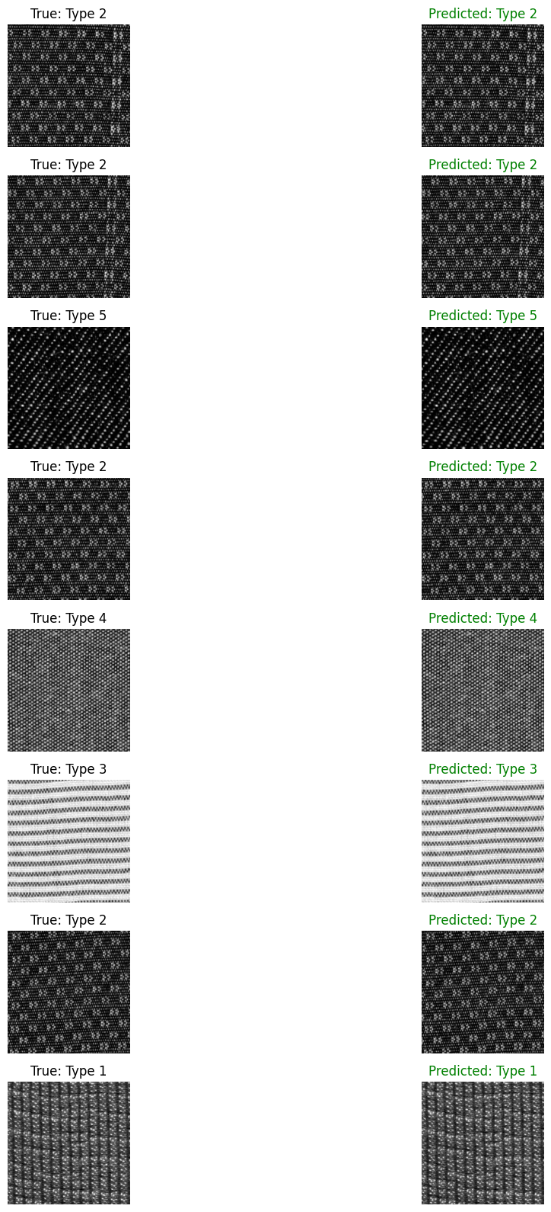
Results and Discussion
Classification Performance
The texture classification system achieved outstanding accuracy:
- Random Forest Accuracy: 100.0%
- SVM Accuracy: 100.0%
This demonstrates that the extracted features effectively capture distinguishing characteristics of each texture type.
Feature Set Comparison
The performance of different feature sets was compared:
- GLCM Features Only: 94.0% accuracy.
- LBP Features Only: 100.0% accuracy.
- Combined Features: 100.0% accuracy.
Key Observations:
- LBP features alone achieved perfect classification accuracy.
- GLCM features provided good but slightly lower accuracy (94%).
- Combining both feature sets maintained the perfect classification performance of LBP.

Conclusion
The texture classification system successfully achieved 100% accuracy on the test set, demonstrating the effectiveness of texture features, particularly LBP, for fabric classification. While both GLCM and LBP features showed good performance, LBP features alone were sufficient for perfect classification in this dataset.
The combination of these feature extraction techniques creates a robust system that could be effectively deployed in industrial settings for automated quality inspection of textile products.
Key Findings
- Local Binary Patterns (LBP) provided perfect discrimination between the five texture classes
- GLCM features offered complementary information but with slightly lower accuracy
- The feature fusion approach maintained optimal performance while potentially offering better generalization for more diverse datasets
Real World applications
1. Textile Industry - Automated Quality Inspection
2. Medical Image Analysis
3. Agriculture - Crop and Soil Analysis

